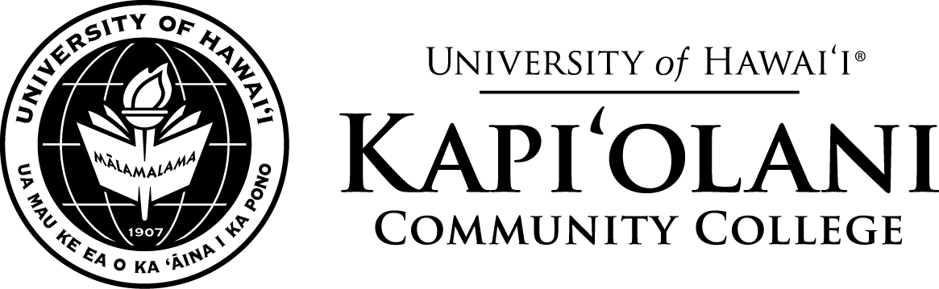
memorandum
March 28, 2019

To: Kapi‘olani Community College Faculty, Staff and Administrators

Subject: Clarification of the Vice Chancellor for Academic Affairs Recruitment Process

After a thorough review of application materials and interviews with potential candidates, the Search Committee conducting the recruitment for the position of Vice Chancellor recommended and advanced four qualified finalists for consideration: two candidates external to the University of Hawai‘i and two internal candidates. Both of the two external candidates withdrew prior to the final interviews for various reasons.

As a result, on March 29, 2019, the final interviews for the VCAA position was conducted with the remaining two internal candidates.

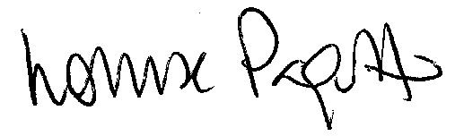
Louise Pagotto
Chancellor

