NEʻEPAPA KALĀHŪ

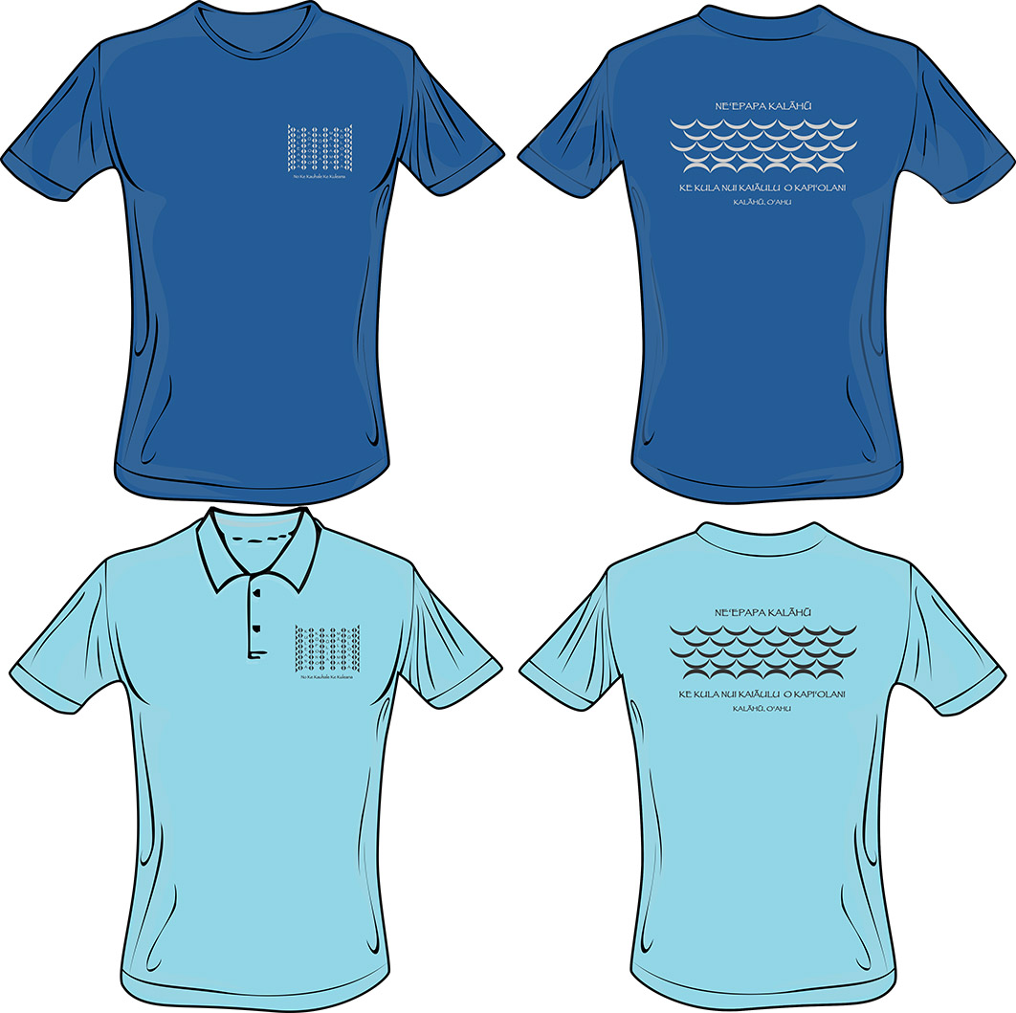

Name:
Department: Campus Mailbox Location:
Extension #: Email Address:

Hanes Tagless Tshirt/ Hanes Comfortblend Polo | Small | Medium | Large | XL | XXL | Total
Neʻepapa Kalāhū Tshirt
(Denim Blue) - $20.00
Sale Price - $10.00
Neʻepapa Kalāhū Polo
(Light Blue) - $25.00
Sale Price - $20.00

Please drop off orders to Derek Lee, ʻIlima 202C

